Building your LinkedIn Summary
Step 1: BRAND YOU

The summary is where people look to find out what makes you tick. Think of the summary as a way of selling yourself—it’s an opportunity to express your voice and personality. You can think of it as a “60-second commercial” selling brand “You.” You have 2000 characters available to you in this space, so use them to highlight you!

Personal branding is THE way to stand out above your competition in a tough job market.

One of the great things about personal branding is that it helps generate chemistry for you by spotlighting your “softer” skills. Employers look for candidates who will be an overall best-fit for their organization. They want more than the right skill sets, knowledge base, and experience. They want people who will fit their corporate culture, so they want to know what kind of person you are. People hire people they like. Your brand helps them assess your fit.

Your brand is your reputation—the combination of personal attributes values, drivers, strengths, and passions you draw from that differentiate your unique promise of value from your peers.

It’s up to you to identify those qualities and characteristics within you, integrate your value proposition in everything you do, and communicate a crystal clear, consistent message across multiple channels—online and offline—designed to resonate with your target audience.

Remember the 3 Cs of personal branding:
Clarity – be clear about who you are and who you are not.
Consistency – steadfastly express your brand across all communications channels—online and offline.
Constancy – strong brands are always visible to their target audience.
Step 2: STYLISTIC SUMMARY OPTIONS

Your summary is a reflection of you and your brand. Consider matching your summary style to your brand. There are many ways to approach your summary; below are some stylistic summary ideas. Regardless of the style or format you choose, the summary should be written in first person.

Sub-headers and Taglines:

The LinkedIn summary is trending toward replacing the use of the lengthy paragraph. Profile viewers are often just stopping by for a quick scroll through your work history, but LinkedIn doesn't give the option to bold, underline, or offer other formatting options within the Summary section. The idea is to help out the reader by making your profile digestible and not to expect anyone to read a big block of text with no graphic interest. Breaking it up (with Headers, Sub-headers and Graphics) makes it visually easy to read; so before writing your Summary, think of some effective headlines and taglines that will help the reader scan your profile and gain interest in you.

Here are some examples of headers:
PROCUREMENT AND TREASURY SPECIALIST: Increasing the Bottom Line on Global Accounts
***************************************************************************************************************************
CREATIVE, STRATEGIC MARKETER | OUT-OF-THE-BOX CORPORATE IDENTITY DESIGNER
***************************************************************************************************************************
BUSINESS-SAVVY CORPORATE COUNSEL: MANAGING LEGAL ISSUES TO ADVANCE CORPORATE GOALS
***************************************************************************************************************************
Step 3: LIST OF SPECIALTIES OR EXPERTISE

Consider including an easy-to-read list of specialties at the end of your summary, which helps tie up any loose ends and is beneficial for SEO.
Step 4: A CALL TO ACTION AND CONTACT INFORMATION

At the end of the summary, the reader must have a strong idea of who you are and how you help people. Ending with a Call to Action (CTA) is an effective way to wrap up your summary. For example:

"If you need help setting up webinars/webcasts, managing them, moderating them, talk to me.”

SUMMARY SAMPLES

Sample 1: What you won’t find on my resume:

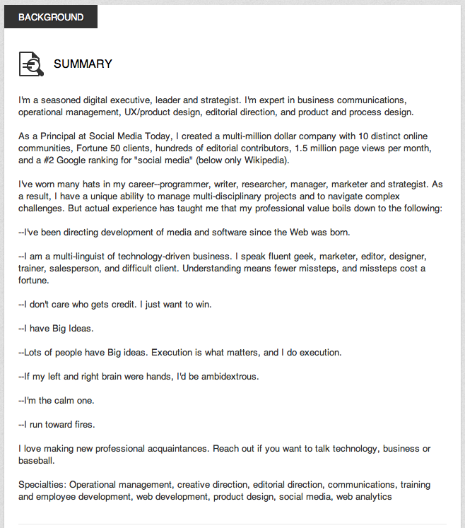
Sample 2: Storytelling

The summer I was 12 years old, my family rented an RV; I was one of four kids so discretionary funds for vacations were modest – we stayed at campsites. One of our destinations, the River Walk in San Antonio, was lined with expensive restaurants and hotels. It was the first time I’d ever stepped foot in a luxury hotel, and I remember thinking – this is where I want to be. That was the day I decided to work in the hotel & travel industry.

My first job at XYZ company – considered one of the “thought leaders in travel” with aggressive investments in travel technology – is where I was bitten by the technology bug and my passion for continual improvement and customer satisfaction gave rise to a 15 year career as an Operations and Customer Service Leader.

- Operational Leadership

Every day, I practice what I am passionate about – creating and implementing systems and procedures that enable effective change. My customer-centric approach and ability recruit strong talent and build successful teams are what led me to my current role as SVP of Customer Success at ABC Inc – one of the world’s leading events and travel technology providers.

I attribute my career success to my leadership philosophy which is grounded in integrity, insightfulness, attentiveness, and collaboration. I value being part of an organization that strives to be a leader in its sector, exceeds customer expectations, values employee development and team optimization, and where I can apply my collaborative leadership style, business acumen, and expertise in operational management to help drive company-wide augmentation.

Customer Management | Operations Metrics | Mergers & Acquisitions Integration | Process Transformation & Cultural Change | P & L Management | Strategic Planning & Execution | Project Management | Global Leadership | Team Development
Contact me to advance your organizations support and service delivery, operational process, growth & profitability emailaddress.com.
Sample 3: Using symbols and taglines

► I am a writer
I write resumes, social media profiles, cover letters, and professional biographies for a living. “Who likes writing resumes?” is the typical response. Well, I do. In fact, I love my job.
Writing is not just my job, it’s my passion. A strategic and analytical thinker at heart, business publications writing allows me to merge those attributes with my creative writing abilities. My greatest asset is my ability to see the potential of any basic structure. For my clients, that means leading the transformation process of their tangible career transition materials from ordinary to extraordinary.
I am an experienced business publications writer and editor specializing in the development of career transition marketing portfolio content, including: resumes, cover letters, social media profiles (LinkedIn), and executive biographies. I successfully partner with diverse populations of individuals and professionals, in a variety of industries to meet career transition goals. Additionally, I have reviewed, written, and edited over 500 undergraduate and graduate student resumes and currently provide support services to Business Schools and University Career Centers.
► I can help
My professional writing services are available on a retail basis to individuals in career transition and in need of professional marketing materials and documents. I, also, offer freelance writing to help small businesses develop competitive marketing collateral, including website content creation or editing.
Writing | Editing | Career Transition Marketing Portfolio Development | LinkedIn Profile Development | Web Content Writing & Editing |
► Contact me
For inquires regarding Career Marketing Portfolio development, email me at emailaddress.com or through my website at www.xxxxxx.
Sample 4:

Building Strategic Relationships, High-Performance Sales Teams & Account Sales

- I am beverage Sales Manager with over 20 years of progressive experience in all 3 segments of the beverage industry – supply, distribution, and retail.

- I know sales and possess an acute understanding of the technologies, applications, and practices used to collect, integrate, analyze, and present sales information.

- I know the beverage industry asserting comprehensive knowledge of brand imaging, product presentations, pricing, and promotions to successfully develop and execute business action plans and facilitate innovative product launches.

- I build sustainable B2B relationships through establishing and maintaining a foundation of trust and integrity and successfully leverage those relationships into revenue streams...
- I develop high-performance sales teams and effectively lead those long-term, bottom-line driven teams to deliver increased market share and profitability.

- I drive new business through executing aggressive marketing and sales initiatives that deliver revenue, market share growth, and market penetration.

New Business Development | Sales Team Management | Strategic Planning | Customer Relationships | Market Share Expansion | Account / Territory Management | Sales Intelligence | Product Positioning Product Launches | Budgeting | Forecasting | Planning | Staff Development & Training | Operations / Logistics Management

Currently, I welcome conversations that will lead to my next professional opportunity. I am open to relocation and travel. If I can't be of service, I may know others who can meet your needs. After all, creating and fostering relationships and giving back are the cornerstones of conducting business today. Please contact me at emailaddress.com.
Sample 5:
Building Profitable Start-Ups | Growing Business Lines | Streamlining Operations
I am Business Development Executive with the ability to successfully lead and develop infrastructure strategy and procedures, formulate and oversee strategies for seed funding, and navigate dynamic and ambiguous environments with an ability to quickly assess and adapt to new business requirements and priorities as needed.
I believe that a successful business is built from a solid, effective foundation, a team oriented environment that is conducive to innovation, and the ideals of customer satisfaction. As a founding, managing partner in a technology start-up, I’ve leveraged my analytical skills and technical foundation to successfully evaluate critical support requirements, identify deficiencies and potential opportunities, and develop and deliver effective solutions and insights.
• Built pro forma models and played integral role in presenting proposals securing angel investment funding to develop business intelligence software and services start-up.
• Led evolution of technology platform and remains current on emerging technologies benefiting organization’s offerings including ensuring technology platforms and peripherals continue in the forefront of the industry.
Business Development | Early Stage Start-ups | Strategic Planning | Business Operations
Revenue Growth | Due Diligence | Technology Implementation | Emerging Technologies
Product Development | Business Intelligence | Data Analytics
Sample 6:

Summary

As a native of Hilton Head Island, I have an undeniable reverence for my low country community. My family opened the first Insurance Agency – Coastal Plains Insurance – on Hilton Head Island in 1968, and I continue to carry on our family’s traditions, today. Insurance has been a part of my personal and professional landscape, for as long as I can remember. My earliest introduction to insurance was around the family dinner table, fostering what have become extensive competencies in both Personal and Commercial Lines. My first position at Costal Plains Insurance was leading the Personal Lines department developing the high net-worth homeowner’s program, and, today, I am proud to be one of their top-performing Commercial Account Executives. I pride myself on maintaining our family’s long-standing, exemplary reputation for consummate professionalism, superior ethical standards, and comprehensive knowledge of insurance products, services, and best practices. I continually strive to meet and exceed targeted goals and customer expectations.
VALUE TO ORGANIZATION
* New Business Development: Adept at identifying and capturing new business opportunities that successfully drive business expansion through executing aggressive marketing and sales initiatives.
*Account Management: Highly effective at establishing and maintaining customer relationships, securing major accounts, and protecting key accounts. Strengths in executing entire sales cycle including prospecting, proposing, presenting, closing, and follow-up.
*Sales Talent: Proven sales talent in cultivating strategic relationships, increasing customer base, and maximizing account sales. Possess exemplary reputation for consummate professionalism and superior ethical standards.
New Business Development | Strategic Sales Planning | Market Analysis | Customer Relationships | High-Impact Presentations | Account Retention | Account / Territory Management |
Consultative Selling | Closing
Sample 7:

Over 17 years holding leadership positions in a private company, public Fortune 1000 company, and as a Naval Officer.
With a strong foundation of management serving over 7 years in the Navy, I transitioned to a national leading luxury homebuilder and oversaw all aspects of the construction process – acquisitions, land development, sales, construction, and P&L. I also led the U.S. operations for a global company specializing in energy efficiency improvements in existing buildings.
In 2014, I leveraged my background in business development, construction services, operations, and sustainable building to create a residential real estate development company with a focus on building energy efficient properties.
XYZ LLC is a rapidly growing real estate acquisition and development company that seeks to create value through the attainment and redevelopment of real estate assets. Our portfolio includes single family and
Multi-family properties.
Our expertise includes:
♦ Acquisitions, Development, Financing, and Construction Management
♦ Construction, Sales, Marketing, Land Development, and Customer Relations in Residential
Developments
♦ Contract Negotiations
♦ Liaising with Local Municipalities and Government Officials to request and secure required
permits and approvals
♦ Energy Efficiency Retrofit Analysis, Services, and Installations on Residential and Commercial
Properties
Areas of Interest: Distressed Properties | Investment Sales | Real Estate Assets | Complete Life Cycle from Site Acquisition to Project Disposition | New Construction | Construction Administration | Rehabs | Sustainable Building
I am always looking for multi-family rentals, subdivisions, and value-add distressed residential real estate investment opportunities. If you would like to connect, please contact me at email address.

Sample 8: Starting with a Question or a Teaser

Summary
Are you seeking a new role?
Taking the next step in your career?
Want clarity about your brand and how to communicate your value profile in a constantly shifting job market?
Looking for a plan and feedback to inspire action?
* I have partnered with professionals in the US and Internationally since 1995 to catalyze their success in job search, executive development and career management.
* Clients include C-level, SVP, VP, Finance, Sales, Marketing, IT, HR, Director, Manager, Business Owners, Science and Biotech Leaders, Education and Association/Non-Profit.
Specialties: Career Transition | Resume Writing | Job Search Strategy | Career Reinvention | Executive Brand Development | Team Vision, Mission Facilitation | Leadership Development | Outplacement | Emotional Intelligence | Purpose & Calling | Interviewing | MBA & EMBA Careers | MBTI |

